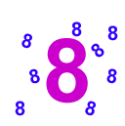
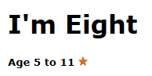
Hands up if you are 8
How many people do you know who are 8?
Find as many ways as you can to make 8.
Example - You might think of 6 + 2, or 22 - 14 or...
Perhaps you could challenge yourself to find ways of making 8 that you think no-one else will have thought of.

If you are not 8 years old, you might like to use your age instead of 8.
Extra challenge
Use the ages of people in your family
I would use 49, 22 and 17

